0504
Steadman by Hanes
50/50 Jersey Knit Sport Shirt
With Pocket

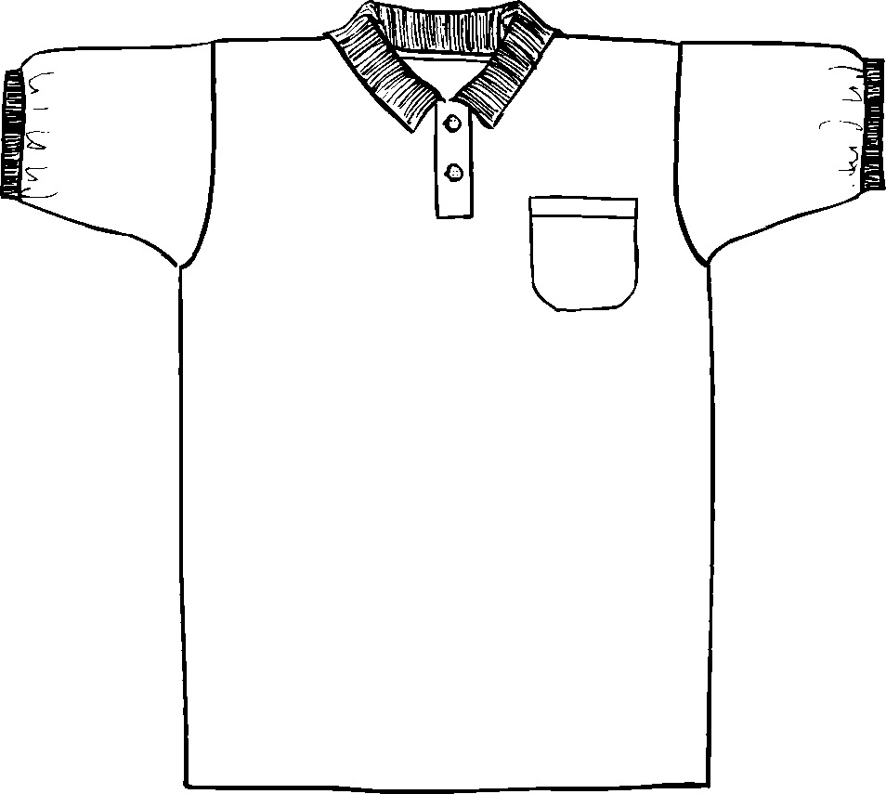

Description
*5.5oz
*50/50 poly/cotton blend
*Welt collar
*Rib knit cuffs
*Unclean placket
*Taped neck & shoulders
*Double needle hem bottom
*Woodtone
*Tubular

Finished Garment Measurements

Size | S | M | L | XL | 2XL | 3XL
pocket | 5-1/8 x 4-1/2
Width | 20 | 22 | 24 | 26 | 28 | 30
Length | 28 | 29 | 30 | 31 | 32 | 33
Armhole | 10 | 10.50 | 11 | 11.50 | 12 | 12.5
Collar Width | 2.5 | 2.5 | 2.5 | 2.5 | 2.5 | 2.5
Sleeve Length | 17 | 18.50 | 20 | 21 | 22 | 23
Cuff Width | 1 | 1 | 1 | 1 | 1 | 1
Shoulder Width | 17 | 18.50 | 21 | 22 | 23 | 24

